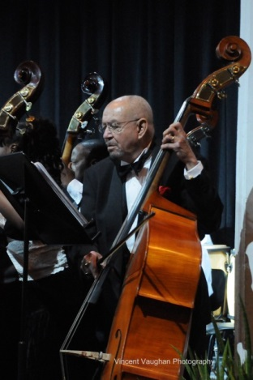
Denis Donaldson was a native Bahamian who truly loved his music. It did not matter if it was classical or jazz; he was ready to play. In his early years, Denis played the saxophone. In a 2008 interview, Denis recalled "We would take our instruments and go over the hill to the Bahamian clubs after the hotel lounges closed. Many tourists and visiting musicians followed us, and players would sit in. We'd jam all night, until the last patron left the place." He played at “over the hill” places like Silver Slipper, Zanzibar, the Cat and Fiddle, and Peanuts Taylor’s Drumbeat Club.
Denis with his beloved bass, photo Courtesy of Vincent Vaughan
Denis found his calling as a bassist quite by accident. He was waiting to play saxophone when the bass player failed to show. The bass was sitting on the bandstand so he "had a go at it." Completely self-taught, his talent soon paid off as he became sought after by the great Stan Getz, among others.
Besides playing at local clubs, Denis also made LP records. One of these albums was “Bacchanal at CHEZ PAUL MEERES (Saturday Night in Nassau).” A copy signed by Denis was on EBay in 2013.
In 1991 he joined the Bahamas Concert Orchestra just after it was formed. In 2008, the Bahamas Government bestowed the designation of Bahamas National Symphony Orchestra (BNSO) on the organization. Since the inception of the BCO and the BNSO, Denis was instrumental in helping the symphony expand to what it is today. Denis took the BNSO to perform at the Church of Saint Louis de France in Quebec, Canada, on June 21, 2009. In that same year, he also was deeply involved in the creation of the String School, which provides string lessons to about 20 students every year. The String School is now an independent entity called The Violin Program.
After Denis’s passing in 2012, the orchestra went through some organizational changes that helped it to grow. In the 2013-2014 season, the orchestra will perform seven concerts, which was the same number of performances they were doing when Denis was actively involved in the orchestra. At the BNSO’s last Annual General Meeting, one of the members suggested that the orchestra fund a scholarship in Denis’s name. The BNSO’s Board of Directors approved the concept, and as a result we now have the Denis Donaldson Scholarship to honor his memory.
The one-year scholarship will be awarded to any Bahamian that has been accepted into an accredited classical or jazz undergraduate or graduate music school or department to major in any of the following: a) instrumental or vocal performance b) composition, c) conducting, or d) arrangement. The school can be located in the Bahamas, Canada, United Kingdom, or United States. Online schools must be approved. The scholarship will be based on a combination of need and merit and will be paid directly to the school. Additional information on the scholarship can be obtained by writing to info.bnso@gmail.com.

Taken from Welcome Bahamas-Nassau, Cable Beach & Paradise Island – 2008 http://www.caribbean.com/jsp/feature.jsp?currentDestination=1&&id=995
Ibid

